Image Compression Using VQ-BTC
Sherif A. Mohamed and Moustafa M. Fahmy
IEEE Transactions on Communications, Vol. 43, No. 7, pp. 2177-2182, July 1995
Abstract
Vector quantization (VQ) and block truncation coding (BTC) are successful image compression techniques. However, a reproduced image using VQ or BTC suffers from edge degradation. In this paper, a new technique that combines the advantages of both VQ and BTC to combat this degradation is presented.
- Introduction
• VQ
• BTC
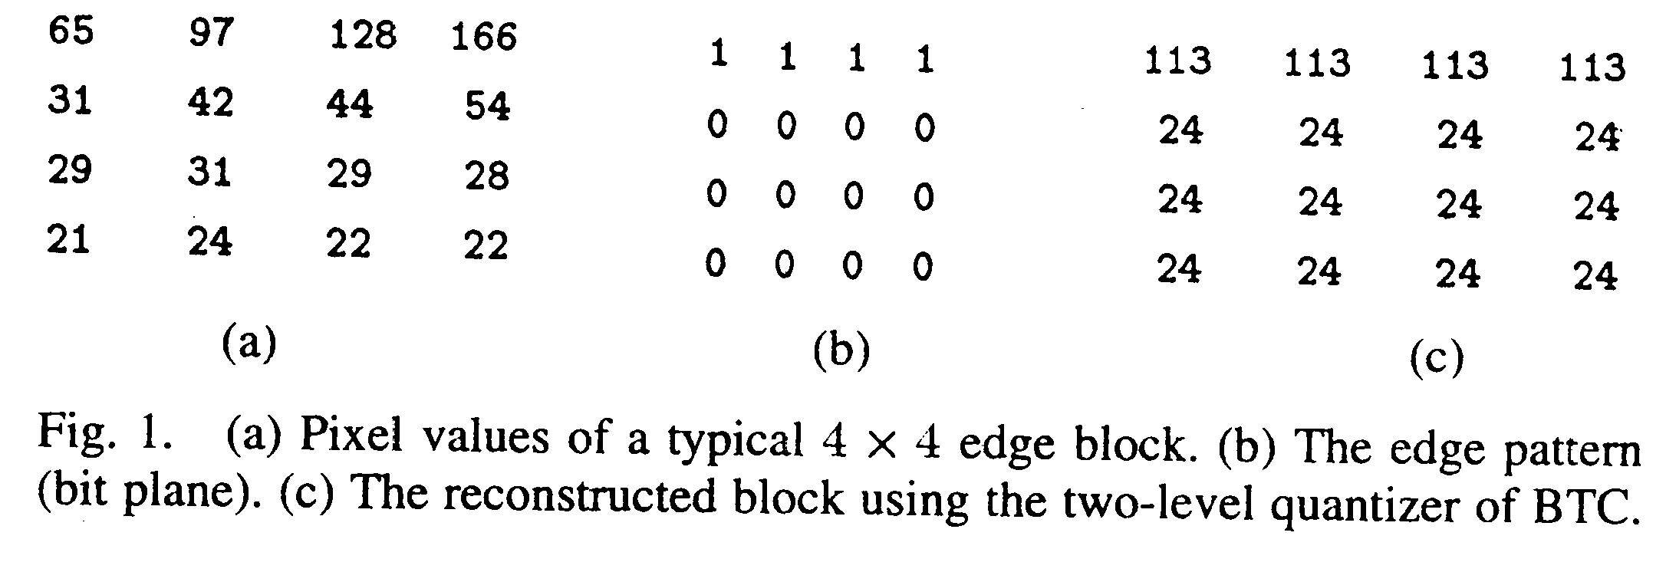
- Basic Idea
BTC is used to preserve the locations of the light and dark pixels inside the edge block and the VQ is applied to encode the light and dark pixels independently.
- Implementation
The input image is partitioned into nonoverlapping 4×4 blocks and then each block is classified as a low-detail or a high-detail block.
• low-detail block: use one moderate size codebook
• high-detail block: use 30 codebooks to encode light vector and dark vector.
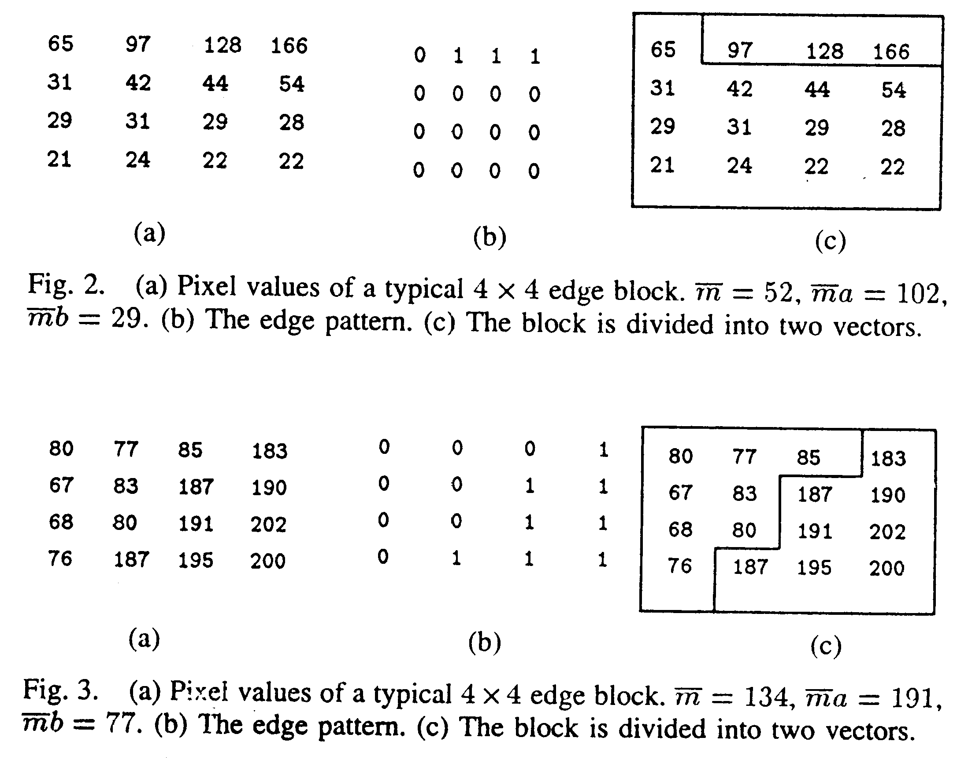

- Experimental Results

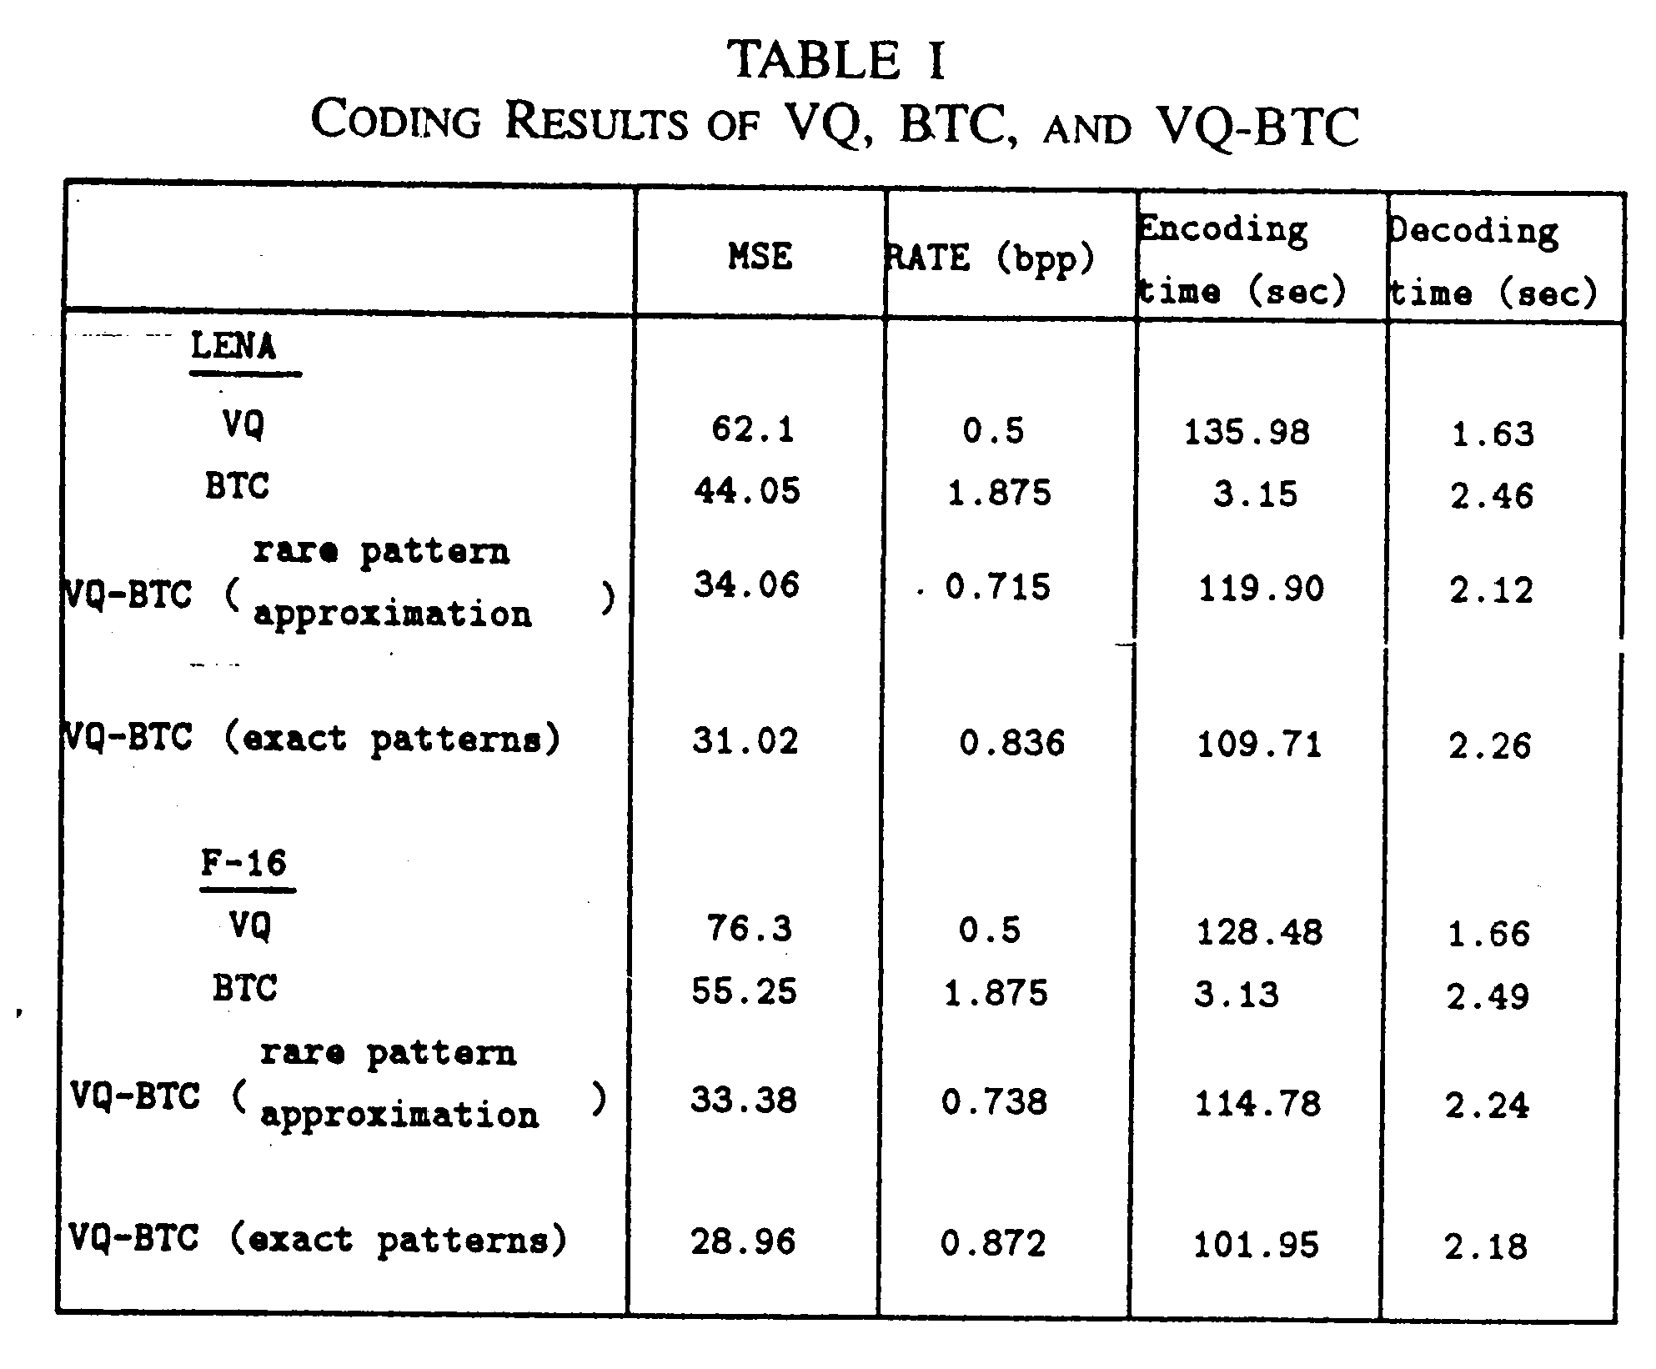

Created by : Chia-Hao Yang
Date : Mar. 17, 1999

